26.18: a) 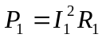
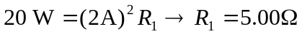
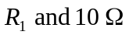 in parallel:
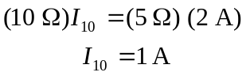
So 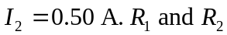 are in parallel, so
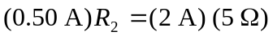
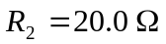
b) 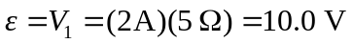
c) From (a): 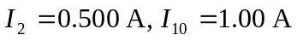
d) 